Title (Arial, bold, size 12, centered)

Presenting Author¹, Name Surname², …¹, Name Surname² (provide Name and Surname for all authors, NO abbreviations) (Arial, size 10)

¹ Affiliation (institution/department, university, city, country), e-mail address of the Corressponding Author (Arial, italic, size 10)
² Affiliation
{mandatory blank line (10p)}
Abstract (Arial, size 10). Please, do not modify the margins. Maximum size of the abstract – 1 page. Citations: [1], [2], etc. Images: minimum resolution of grayscale/color images is 300 dpi.
{mandatory blank line before Figure/Scheme/Table (10p)}
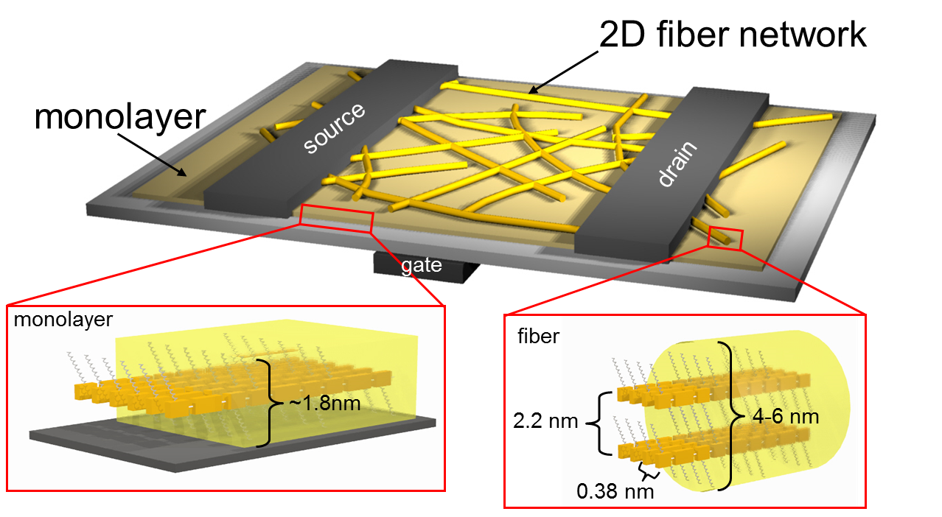
Figure 1. Caption (Arial, size 9, centered).
{mandatory blank line (10p)}
Acknowledgements, grant financing, etc. Arial, size 8, centered, italics
{ mandatory blank line (10p)}
- B. Smith, M. Kowalski, and G. Jones, Adv. Mater. 24, 417 (2012). (Arial, size 8)

